**Title**: Impact of Explicit Health Benefits Package on Support for Universal Health Care

**Authors**: Sean Duan, BS; Victoria A. Shaffer, PhD

**Purpose**: Universal health care (UHC) addresses inequality and bridges the gap in health outcomes between the marginalized and privileged, however, there is a lack of support for UHC in the US. Explicit health benefits packages (HBPs), which clearly define and outline the cost and scope of care, may help improve support for UHC by heightening comprehensibility and increasing perceived equality. We compared support for UHC after exposing participants to either a HBP, dummy activity, or ‘standard’ UHC messaging from the World Health Organization (WHO).

**Method**: Participants in study one (N=189) were either exposed to an HBP or completed a dummy exercise. HBP exposure consisted of either building a HBP, making tradeoffs with limited resources to prioritize care, or were given a completed HBP. Both were asked to assess how this HBP would impact their lives. Participants in study two (N= 412) either built their own HBP or viewed UHC pamphlets from the WHO. Support for UHC was our outcome measure; Perceived equality and comprehensibility were our two proposed mediating factors with numeracy (objective and subjective) as a potential moderator in study two. All measures were on a 0-100 slider bar scale.

**Results**: In study one, participants who were exposed to an HBP were more supportive of UHC, regardless of if they were given one or built their own. In study two there was no main effect of the intervention on support for UHC; *ps* < .05. However, there was a significant interaction between the intervention and objective (but not subjective) numeracy. Greater numeracy predicted increased support for UHC in the intervention versus the control. Lastly, we found evidence of a mediational relationship for perceived equity, but not comprehensibility, on support for UHC.

**Conclusions**: Employing an HBP does seem to have some effect in increasing support for UHC. There is some evidence that an HBP does so by increasing the perceived equity of UHC, perhaps through clear outlines and limits to the scope of care. Furthermore, we see no significant difference between being given an HBP or going through the more involved process of producing one. Our intervention had a significantly greater impact in subjects with higher objective numeracy, suggesting that a different approach is needed to communicate the benefits of UHC to the less numerate.

**Word count**: 375 (375 MAX)

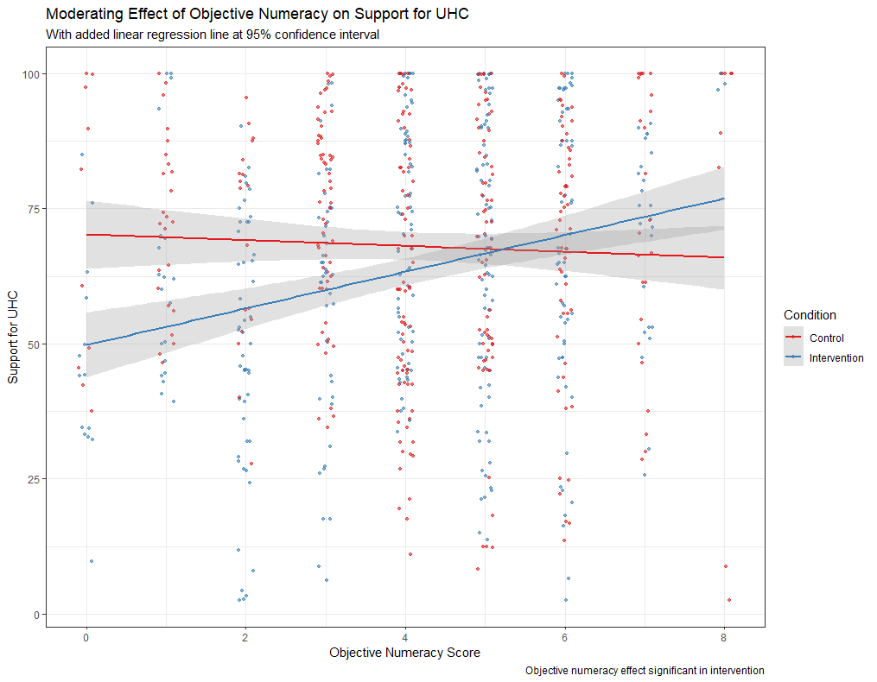Figure 1. Interaction between objective numeracy levels and exposure to explicit health benefit packages on support for universal health care.